Name
STUDENT
HANDOUT

Save Smog City from Ozone!
Adapted from Save Smog City 2 From Ozone
Directions:
- Go to the website www.smogcity2.org
- Click on the link “Save Smog City 2 from Ozone” in the bottom left
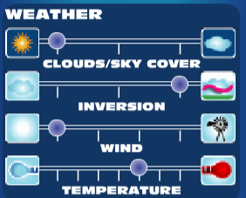
- Look at your controls on the left side of the screen. You have controls for weather, emissions, and population. Try out the controls to make sure you know how they work.
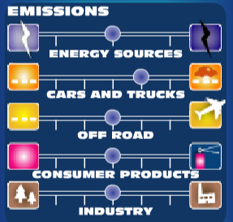

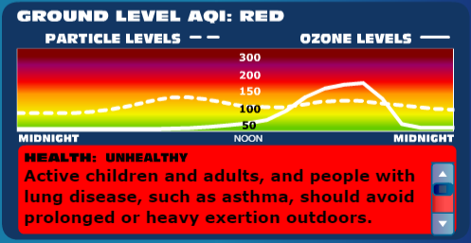
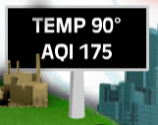
- Look at the information about air quality you have. Find the temperature and AQI information and the ground-level AQI information:

- Find the information box at the bottom of the screen. When you click on any of the controls, you will find information about it.
- Click the reset button in the bottom left. This will reset the controls. Minimize the directions at the top of the screen by clicking on the minus sign:

You’re now ready to save Smog City from Ozone!

Scenario 1: Emissions

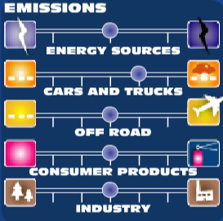
What is the AQI at the start of the scenario?

What color does this AQI represent?

Change some of the emissions controls. What happens to the AQI when the emissions go up or down?

Which kind of emissions changes the AQI the most?

Why do you think this is?

Change the emissions controls so the AQI is in the yellow zone. Draw your settings on the chart below:
Energy Sources:
Cars & Trucks:
Off Road:
Consumer Products:
Industry:

Now change the emissions controls so the AQI is in the green zone. Draw your settings on the chart below:
Energy Sources:
Cars & Trucks:
Off Road:
Consumer Products:
Industry:

Scenario 2: Weather
Click the reset button in the bottom left to set the controls back to their defaults.
Adjust each of the weather controls, and notice how the AQI changes with the weather. Circle how the AQI changes with each weather change:

When it gets more cloudy, the AQI goes up OR goes down (circle one)

When there is a high altitude inversion (a layer of warm air), the AQI goes up OR goes down

When there is high wind, the AQI goes up OR goes down

When there is high temperature, the AQI goes up OR goes down

Find a setting for weather that has an AQI at the green level. Describe what the weather is like:

Find a setting for weather that has an AQI at the red level. Describe what the weather is like:

Look at the graph in the bottom right that shows AQI at different times of day. When is the AQI the worst during the day? Why do you think this is?

Scenario 3: Population
Click the reset button in the bottom left to set the controls back to their defaults.
Use the population settings to raise and lower the population.

When there is higher population, the AQI goes up OR goes down (circle one)

Why do you think population has such a big effect on AQI?
Scenario 1: Emissions
TEACHER
GUIDE

What is the AQI at the start of the scenario? 175

What color does this AQI represent? Red

Change some of the emissions controls. What happens to the AQI when the emissions go up or down?
When the emissions go up, the AQI goes up, and when the emissions go down, the AQI goes down

Which kind of emissions changes the AQI the most? Cars and trucks

Why do you think this is? There are a lot of cars and trucks on the road, and they produce a lot of pollution, so reducing the number of cars can have a big effect on the AQI

Change the emissions controls so the AQI is in the yellow zone. Draw your settings on the chart below:
Energy Sources:
Answers will vary. Cars and trucks will likely be at the lowest or near lowest level.
Cars & Trucks:
Off Road:
Consumer Products:
Industry:

Now change the emissions controls so the AQI is in the green zone. Draw your settings on the chart below:
Energy Sources:
Answers will vary, but will generally be at or near the lowest levels
Cars & Trucks:
Off Road:
Consumer Products:
Industry:

Scenario 2: Weather
Click the reset button in the bottom left to set the controls back to their defaults.
Adjust each of the weather controls, and notice how the AQI changes with the weather. Circle how the AQI changes with each weather change:

When it gets more cloudy, the AQI goes up OR goes down (circle one)

When there is a high altitude inversion (a layer of warm air), the AQI goes up OR goes down

When there is high wind, the AQI goes up OR goes down
Both are true depending on other weather conditions

When there is high temperature, the AQI goes up OR goes down

Find a setting for weather that has an AQI at the green level. Describe what the weather is like:

Answers will vary, but in general, the weather will be windy, with no inversion. It may be cloudy, and the temperature may be moderately warm

Find a setting for weather that has an AQI at the red level. Describe what the weather is like:
Answers will vary, but in general, the weather will not be windy, and there will be a high-altitude inversion. It may be sunny, and the temperature may be either very cold or very hot.

Look at the graph in the bottom right that shows AQI at different times of day. When is the AQI the worst during the day? In the afternoon Why do you think this is? AQI is worst in the afternoon because it is hotter and the sun is more directly overhead

Scenario 3: Population
Click the reset button in the bottom left to set the controls back to their defaults.
Use the population settings to raise and lower the population.

When there is higher population, the AQI goes up OR goes down (circle one)

Why do you think population has such a big effect on AQI? Population has a big effect on AQI because it affects all the other emissions. When there is a bigger population, there are more cars and truck, more electricity is needed, and there are more factories. So population makes all the other emissions factors go up.

