Name
STUDENT
HANDOUT

Rising Temperatures, Rising Tides

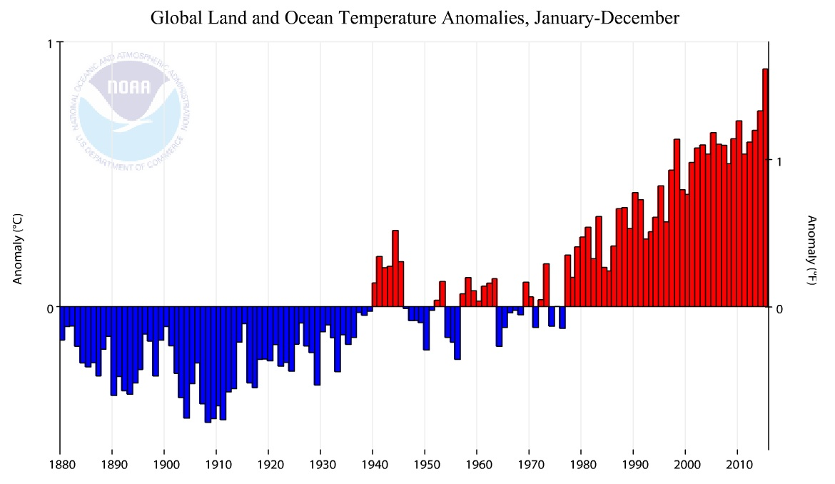

This graph shows whether the temperature in each year is hotter than average or colder than average. If a year is at 0, then it means the temperature is exactly at the average.

- Look at 1880-1940. Is the temperature above or below average for these years?
- Look at 1980-2015. Is the temperature above or below average for these years?
- What is the hottest year you can see?
- How far above average is that year?
- Based on this information, what would you say is happening to the global temperature?

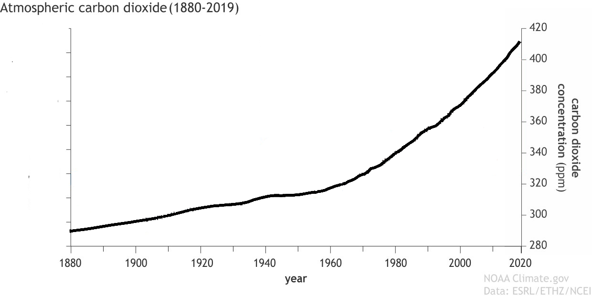

This graph shows the concentration of carbon dioxide in the atmosphere during the same time period.

- How does the concentration of carbon dioxide in the atmosphere change?
- Carbon dioxide concentration is measured in parts per million. What is the lowest concentration in the graph? What is the highest?
- Using your answers from the last question, how much has the concentration of carbon dioxide gone up from 1880-2020?

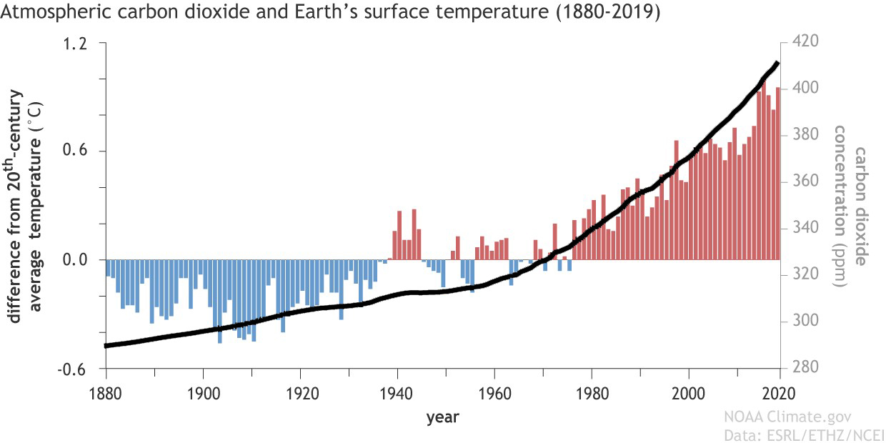

This graph shows the concentration of carbon dioxide in the atmosphere and the temperature at the same time.

- What pattern do you notice in the amount of carbon dioxide in the atmosphere compared to the temperature change?

Reading: Correlation vs. Causation
Scientists noticed that the concentration of carbon dioxide in the atmosphere and the global temperature seem to go together. As one went up, the other went up. When two things seem to go together like this, scientists say that they are correlated. The prefix “co-" means together as in cooperate and copilot. When things are correlated they are related together. If scientists see that things are correlated, they often try to figure out if one thing is causing the other thing.

Just because two things are correlated doesn’t mean one thing is causing the other. For example, students who are in higher grades are also taller. Does that mean that being in a higher grade causes you to be taller? Of course not. There is another factor – your age – that is related to being taller and being in a higher grade.

Can higher carbon dioxide concentrations cause temperatures to rise? That’s a great question to ask. We will learn about that now!

Video: The Greenhouse Effect
Watch the greenhouse effect video and fill in the spaces with the correct information.

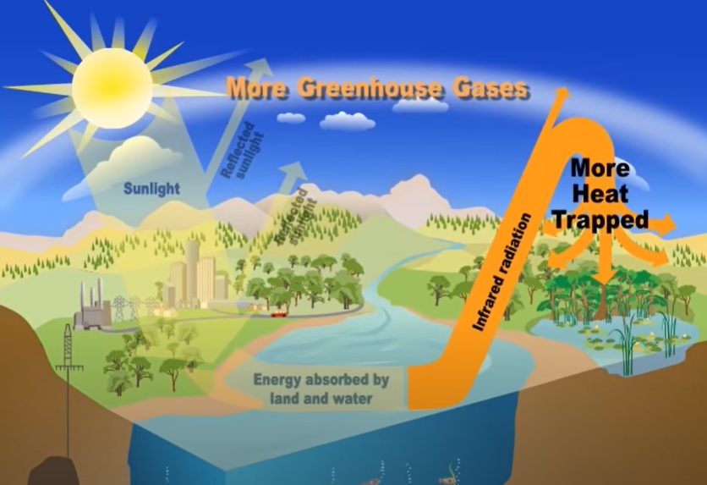

Cause & Effect

Humans produce extra greenhouse gases
Sunny day flooding

