Name
STUDENT
READING

What is Climate Change?

The greenhouse effect is a process that occurs when certain gases in the Earth’s atmosphere trap heat and cause the planet to get warmer. Carbon dioxide (CO₂) is the most important greenhouse gas, but there are other greenhouse gases in the atmosphere such as water vapor, methane, and nitrous oxide. | What are the major greenhouse gases?
When the temperature on the planet goes up, it causes more than just hotter days. There are a lot of different effects that are caused by a warmer Earth. Climates across the planet will be different, so we call these effects “climate change.” Climate change involves changes in long-term weather patterns including temperature, rainfall, and storm activities. | What is climate change?
There are many effects from climate change. Rising sea levels are one example. Melting polar ice in both the Arctic and Antarctic is another. As temperatures rise, we expect there will be more droughts and heat waves, which can lead to wildfires. Many places in the United States will get more rain, although some will get less. Hurricanes are also expected to get stronger. | Name three effects of climate change:
Even though the effects of climate change can feel frightening, there is reason to be hopeful! Millions of people around the world are working to help stop climate change by reducing the amount of carbon dioxide in the atmosphere. Because greenhouse gases are often produced in power plants and vehicles, we can all do our part to reduce climate change by using less electricity, and riding or driving less in cars and trucks. | Name two ways that you can help stop climate change:

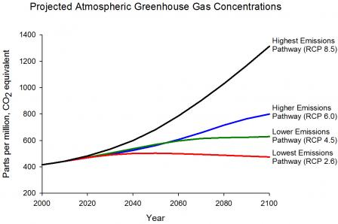

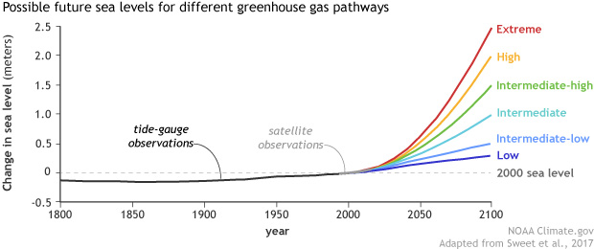
Note: 1 meter is about 3 feet.

What is the predicted change in sea level in feet for the extreme scenario?
What is the predicted change in sea level in feet for the intermediate scenario?
What is the predicted change in sea level in feet for the low scenario?

Name
STUDENT
HANDOUT

Climate Resilience & Sea Level Rise

Community climate resilience: the ability of communities to prepare for, respond to, and recover from hazardous events and adversity related to climate change.

What kinds of things do the people in the video do to prepare for flooding?

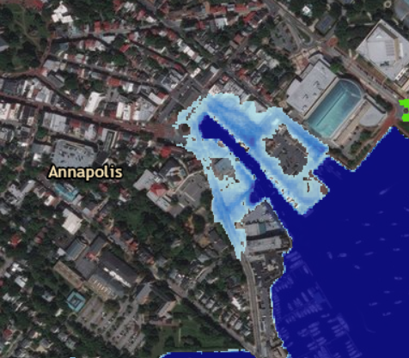
Think back to the sea-level rise scenarios we studied in Annapolis. Imagine that you are a business owner with a store that is in the light blue zone. You want to prepare for the “intermediate” climate change scenario. What kinds of things can you do to make your community more resilient to climate change?

